DATE | 20-02-2026
TEAM ID | LTVIP2026TMIDS90622
PROJECT NAME | SMART SORTING : TRANSFER LEARNING FOR IDENTIFYING ROTTEN FRUITS AND VEGETABLES
MAXIMUM MARKS | 2 MARKS
CHAPTER-6
6.1 PRE-REQUISITES
To complete this project, you must require the following software, concepts, and packages
Anaconda Navigator:Refer to the link below to download Anaconda Navigator
How to Install Anaconda Navigator
Step 1: Download Anaconda
Open your web browser.
Go to: https://www.anaconda.com/download
c

Select your Operating System:
- Windows
- MacOS
- Linux
Download Anaconda Individual Edition (Free). Choose Python 3.x (64-bit) version (recommended).

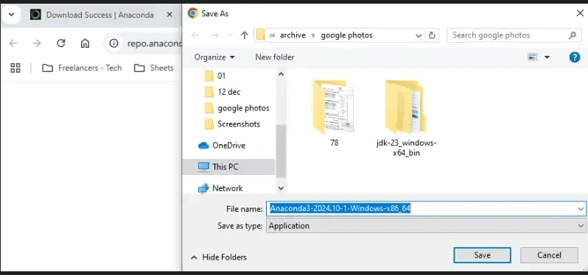
Step 2: Install Anaconda For Windows
Double-click the downloaded .exe file.
Click Next
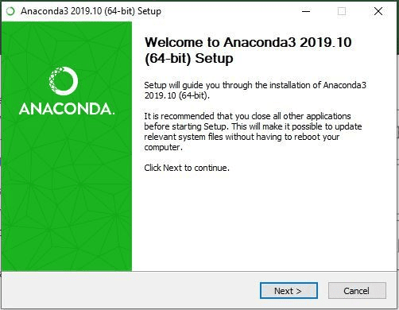
- Click I agree to accept the license.
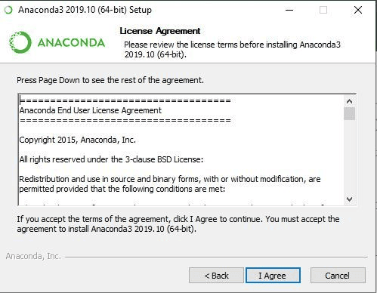
- Select Just Me (recommended) → Click Next.
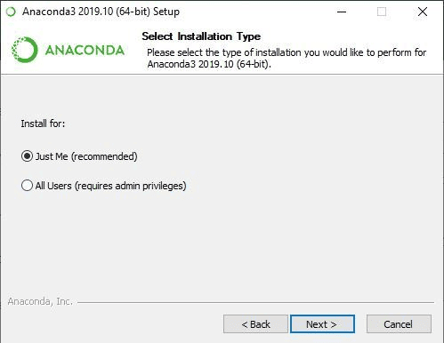
- Choose the installation location where we need to install the anaconda software → Click Next.
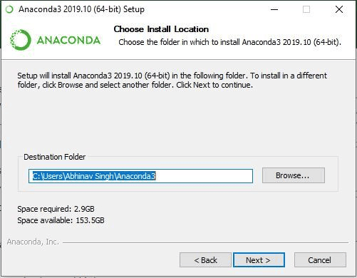
- Check Add Anaconda to PATH (optional but useful).
- Check Register Anaconda as default Python.
- Click Install.

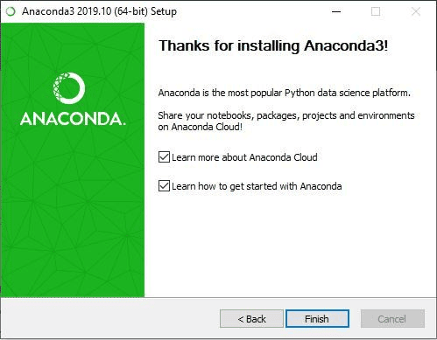

- After installation completes, click Finish.
- Access Anaconda Navigator
- Once the installation process is done, Anaconda can be used to perform multiple operations. To begin using Anaconda, search for Anaconda Navigator from the Start Menu in Windows PC.

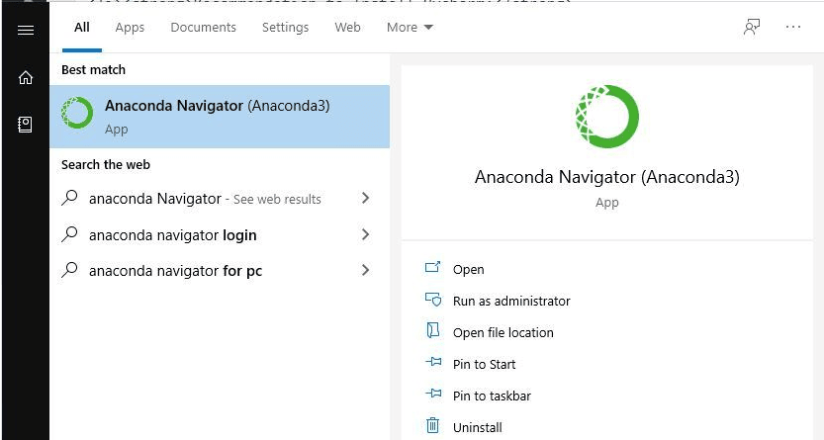
- Explore Navigator & Features
- You can use navigator to create new environments, install packages, and launch applications without using the command line.

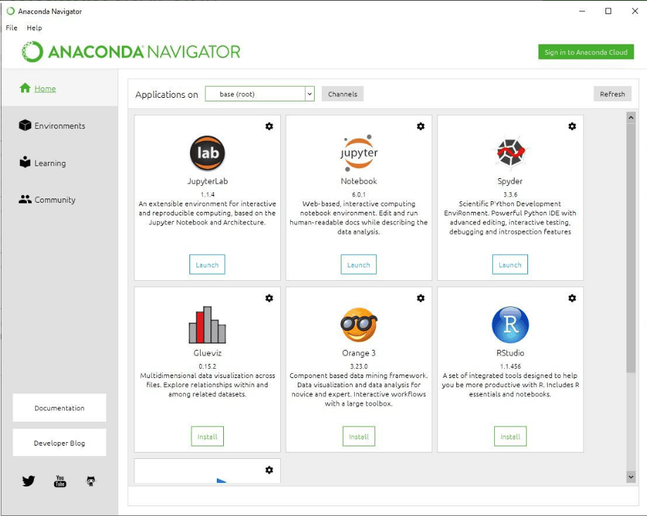

How to install pycharm:
Installing PyCharm on Windows (Detailed Steps)
1. Go to the JetBrains PyCharm website
- Open any web browser (Chrome, Edge, Firefox, etc.).
- Type pycharm.jetbrains.com in the address bar and press Enter.
2. Click Download
- On the PyCharm homepage, you’ll see a Download button.
- Click it to go to the download page.
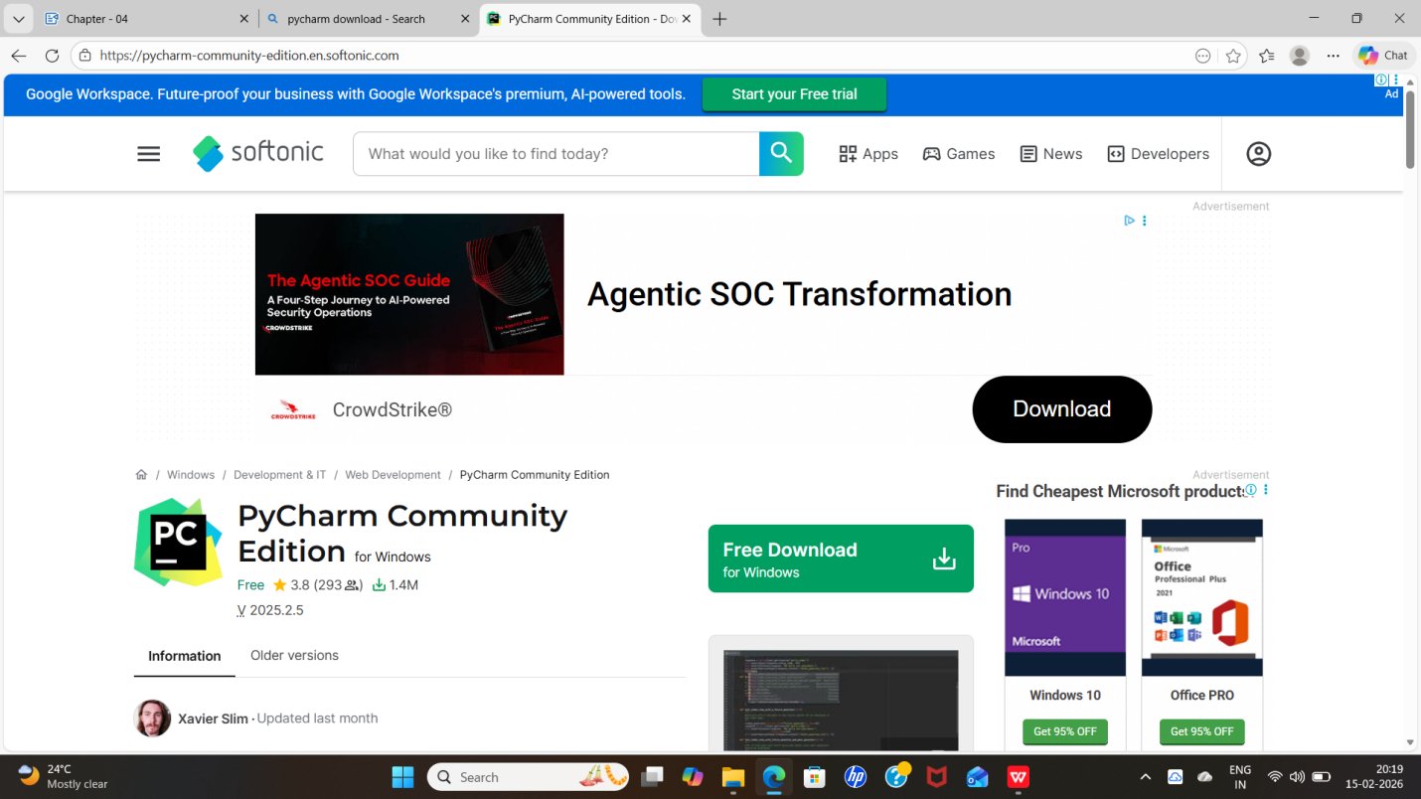
3. Choose Community or Professional
You will see two versions of PyCharm:
PyCharm Community Edition (Free)
Choose this if:
- You are a beginner or student
- You are learning basic Python
- You are doing school projects, scripting, or simple programs
What it includes:
- Python editor
- Code suggestions (auto-complete)
- Debugger
- Basic project tools
4. Download the Windows (.exe) installer
- Under your chosen version, click Download for Windows.
- A file ending in .exe will start downloading.
- Wait for the download to complete.

HOW TO INSTALL THE PACKAGES :
To install the packages , open pycharm
Step-1: click on Terminal .
Step-2: Now, Run the package command one by one and they will start installing in the interpreter
Python packages:
Open anaconda prompt as administrator
Type “pip install numpy” and click enter.
Type “pip install pandas” and click enter.
Type “pip install scikit-learn” and click enter.
Type ”pip install matplotlib” and click enter.
Type ”pip install scipy” and click enter.
Type ”pip install seaborn” and click enter.
Type ”pip install tensorflow” and click enter.
Type “pip install Flask” and click enter.



